**Udacity Healthcare Specification**

High Level Overview

Summary

Screenshot

System Design

Data Collected From User

Description of Key Features

Schedule Appointments

Pay Bills

Message Doctors

Privacy Overview

Data Deletion

Data Export

# 

# High Level Overview

## Summary

Udacity Health, a healthcare company which has patients all over the world has created a web application for their patients. The web application allows the user to perform the following functions:

* Schedule appointments
* Pay bills
* Message doctors

The application will also use AI to recommend schedules and to determine whether the patient needs to see a doctor. Answers from a questionnaire asked before scheduling an appointment will be used in the AI algorithm.

## Screenshot

Image 1

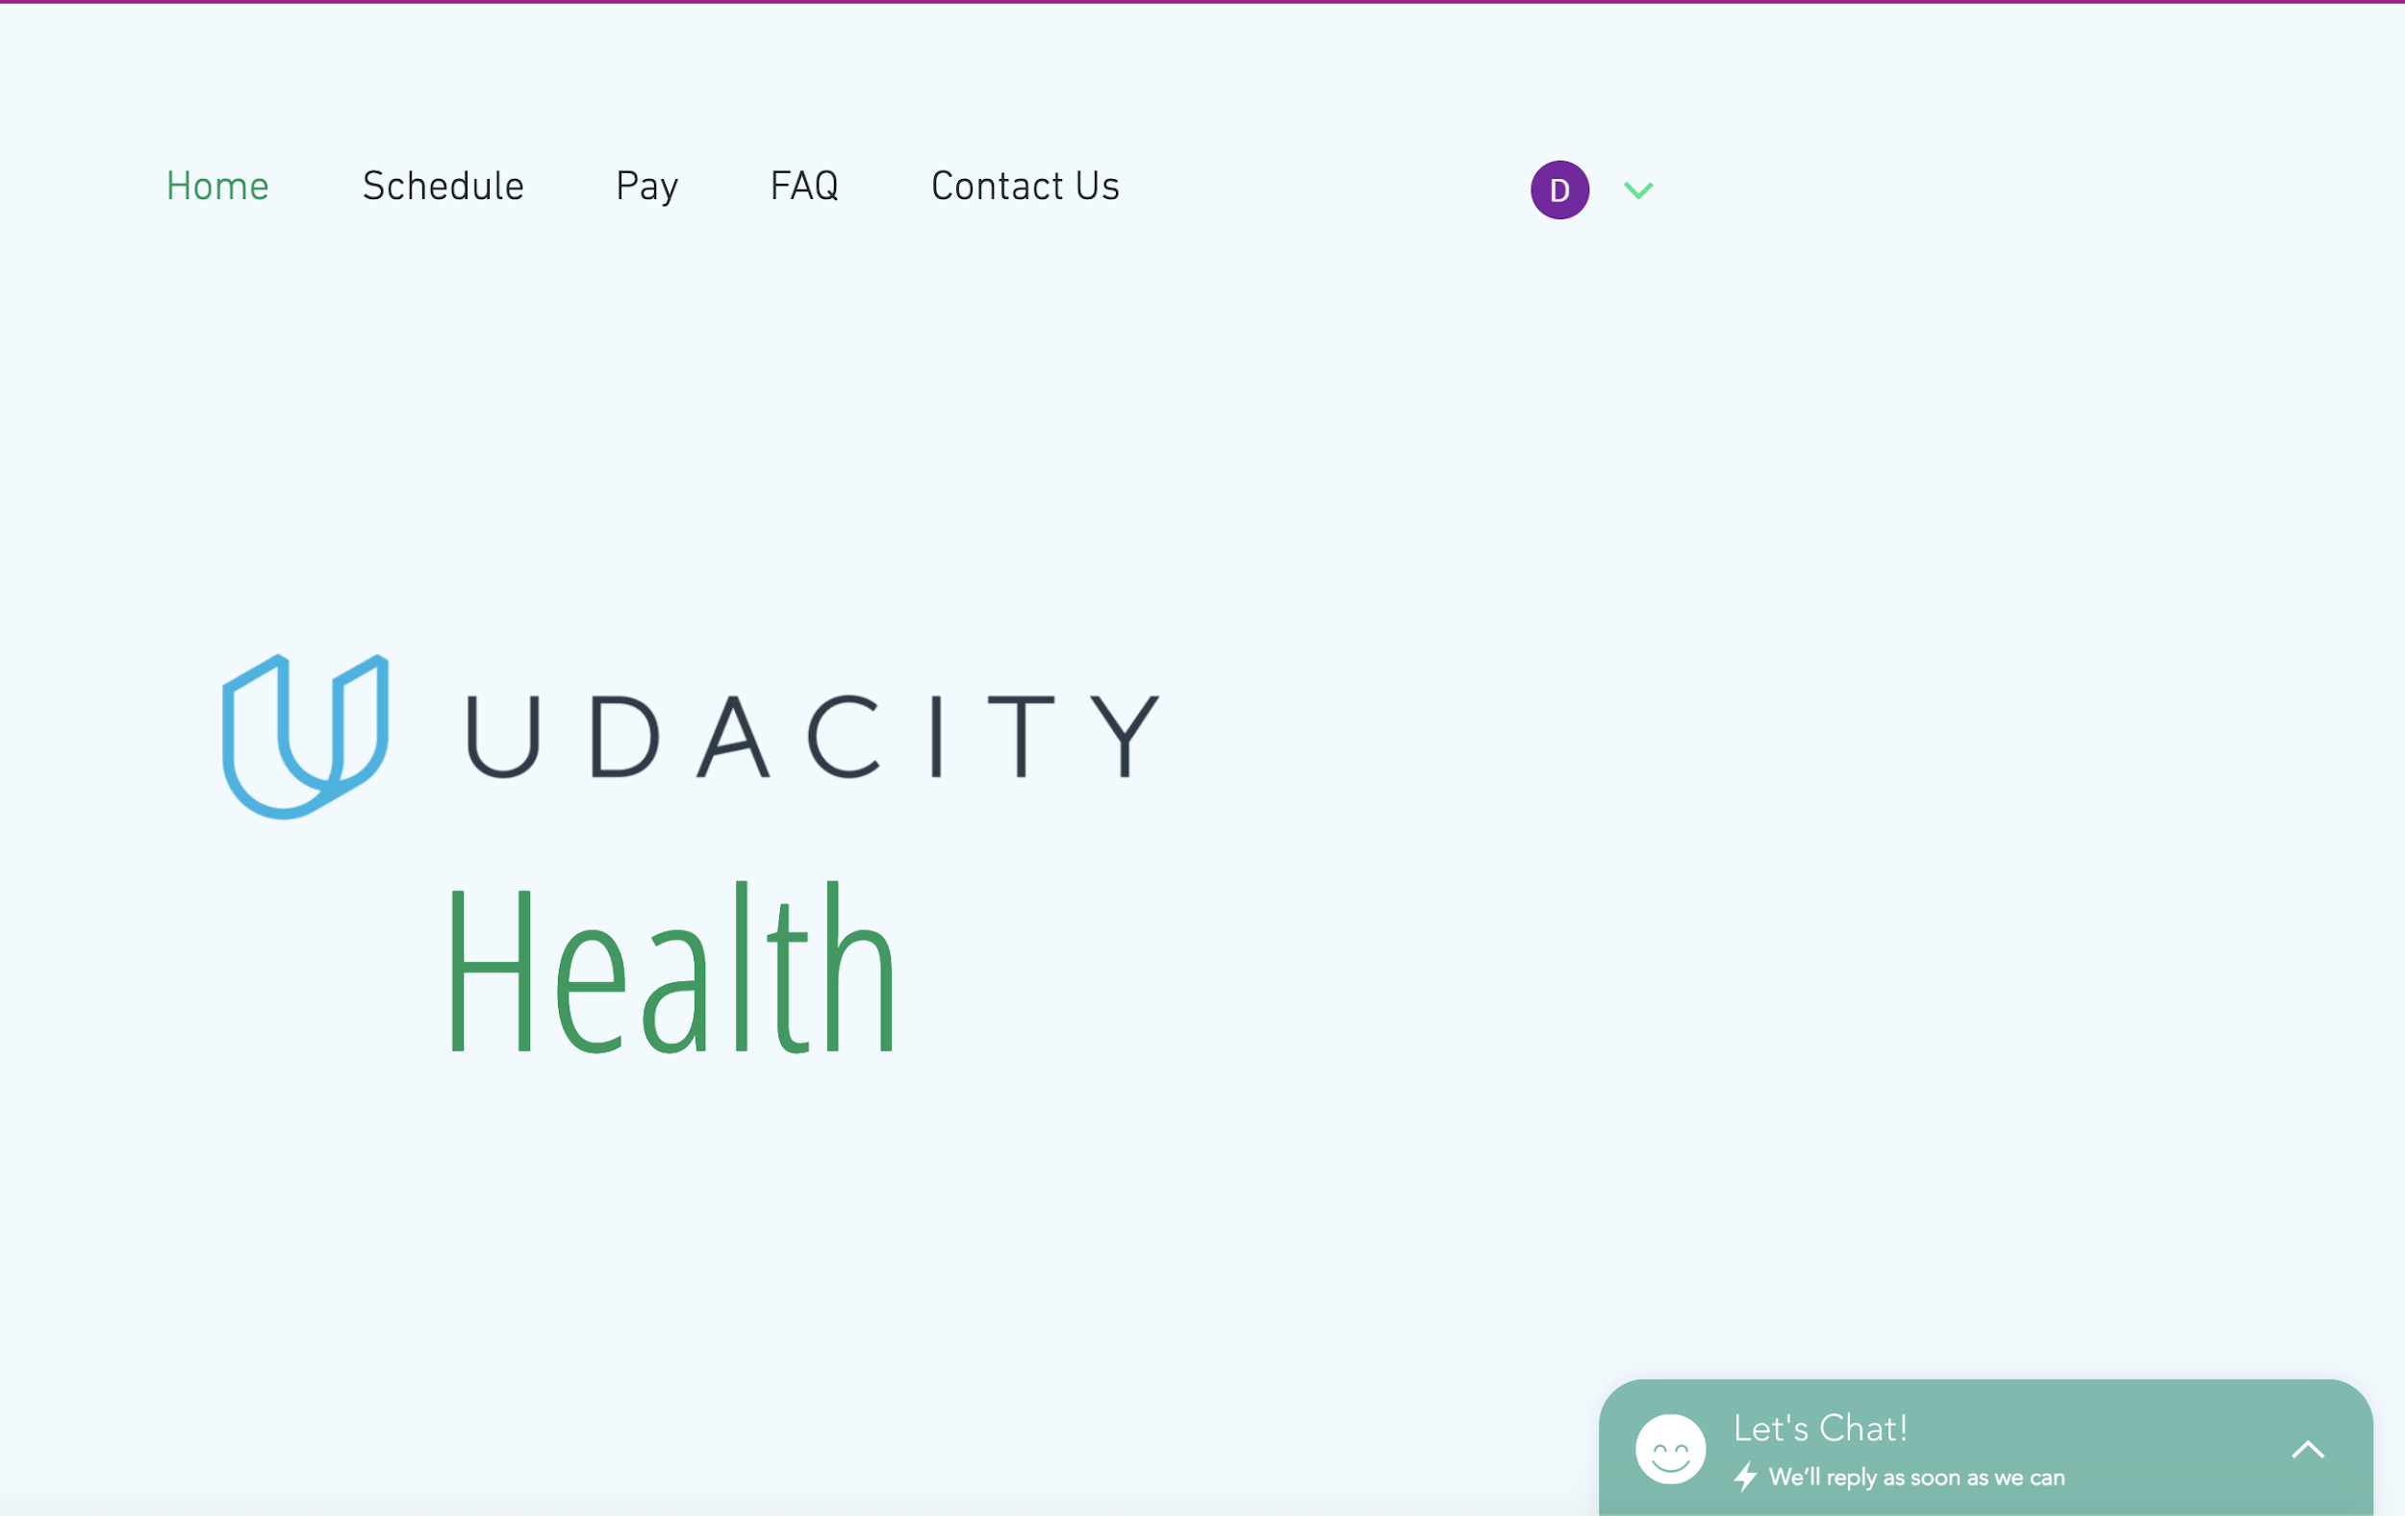

Details of Image 1:

* Udacity Health main landing page for visitors to the site
* Only 1 pop-up on the page which is to chat with a health professional
* Menu items on the page are to:
  + Schedule
  + Pay
  + FAQ
  + Contact Us

Image 2

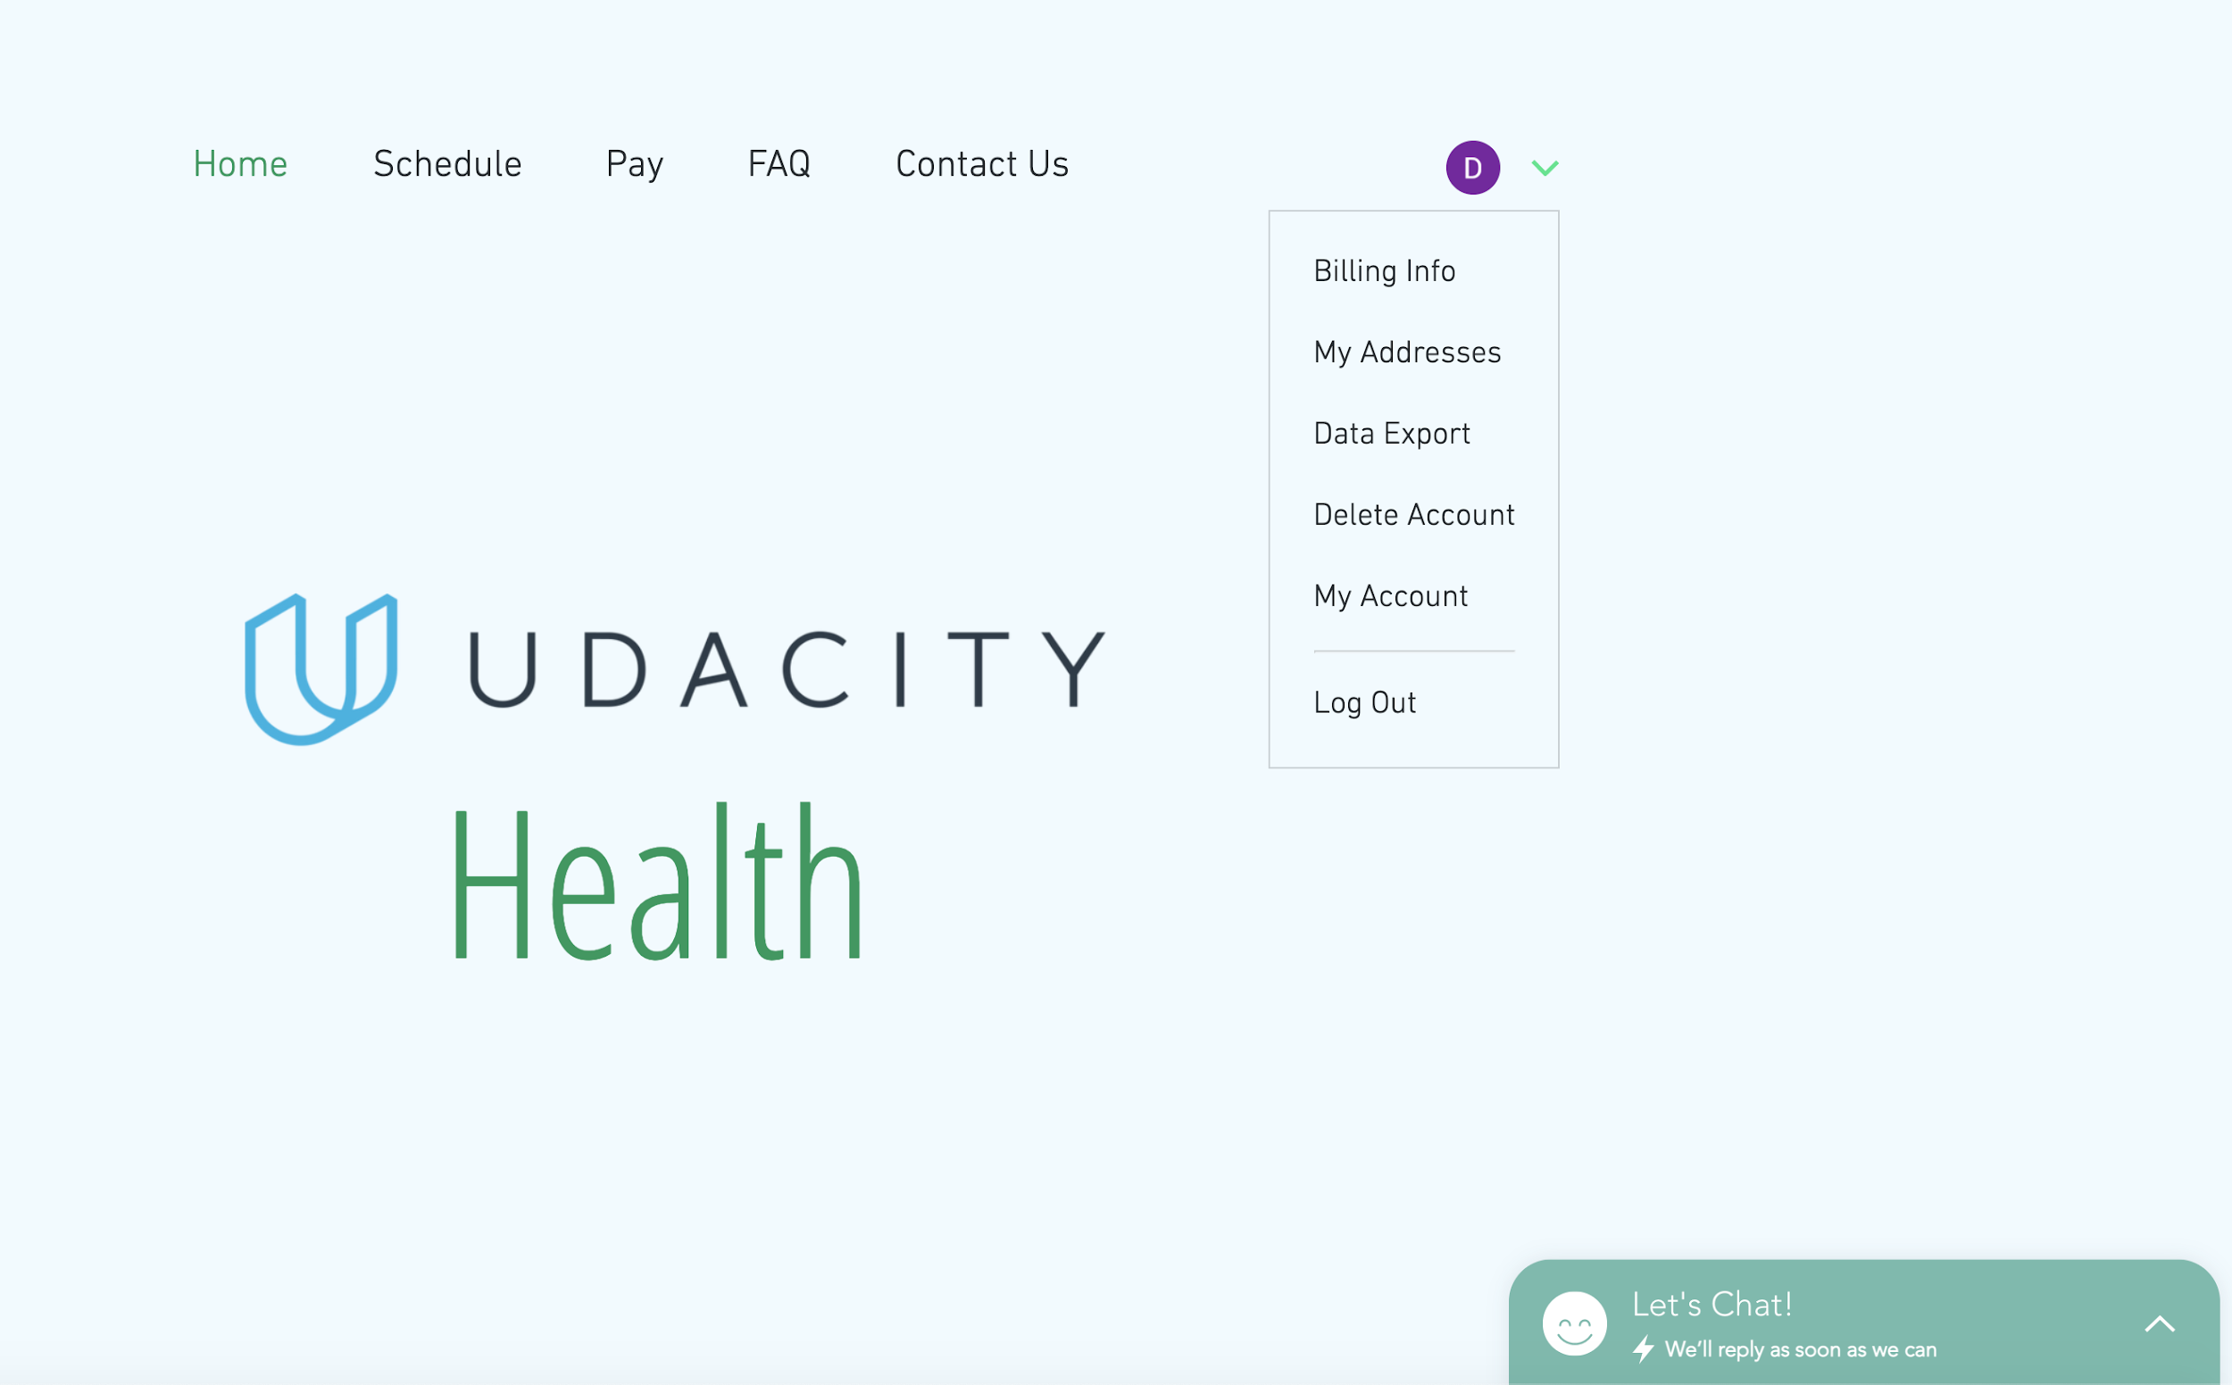

Details of Image 2:

* Main landing page with mouse over User initial.
* A menu is displayed with Account options for the user
  + Billing Info
  + My Address
  + Data Export
  + Delete Account
  + My Account
  + Log Out

Image 3

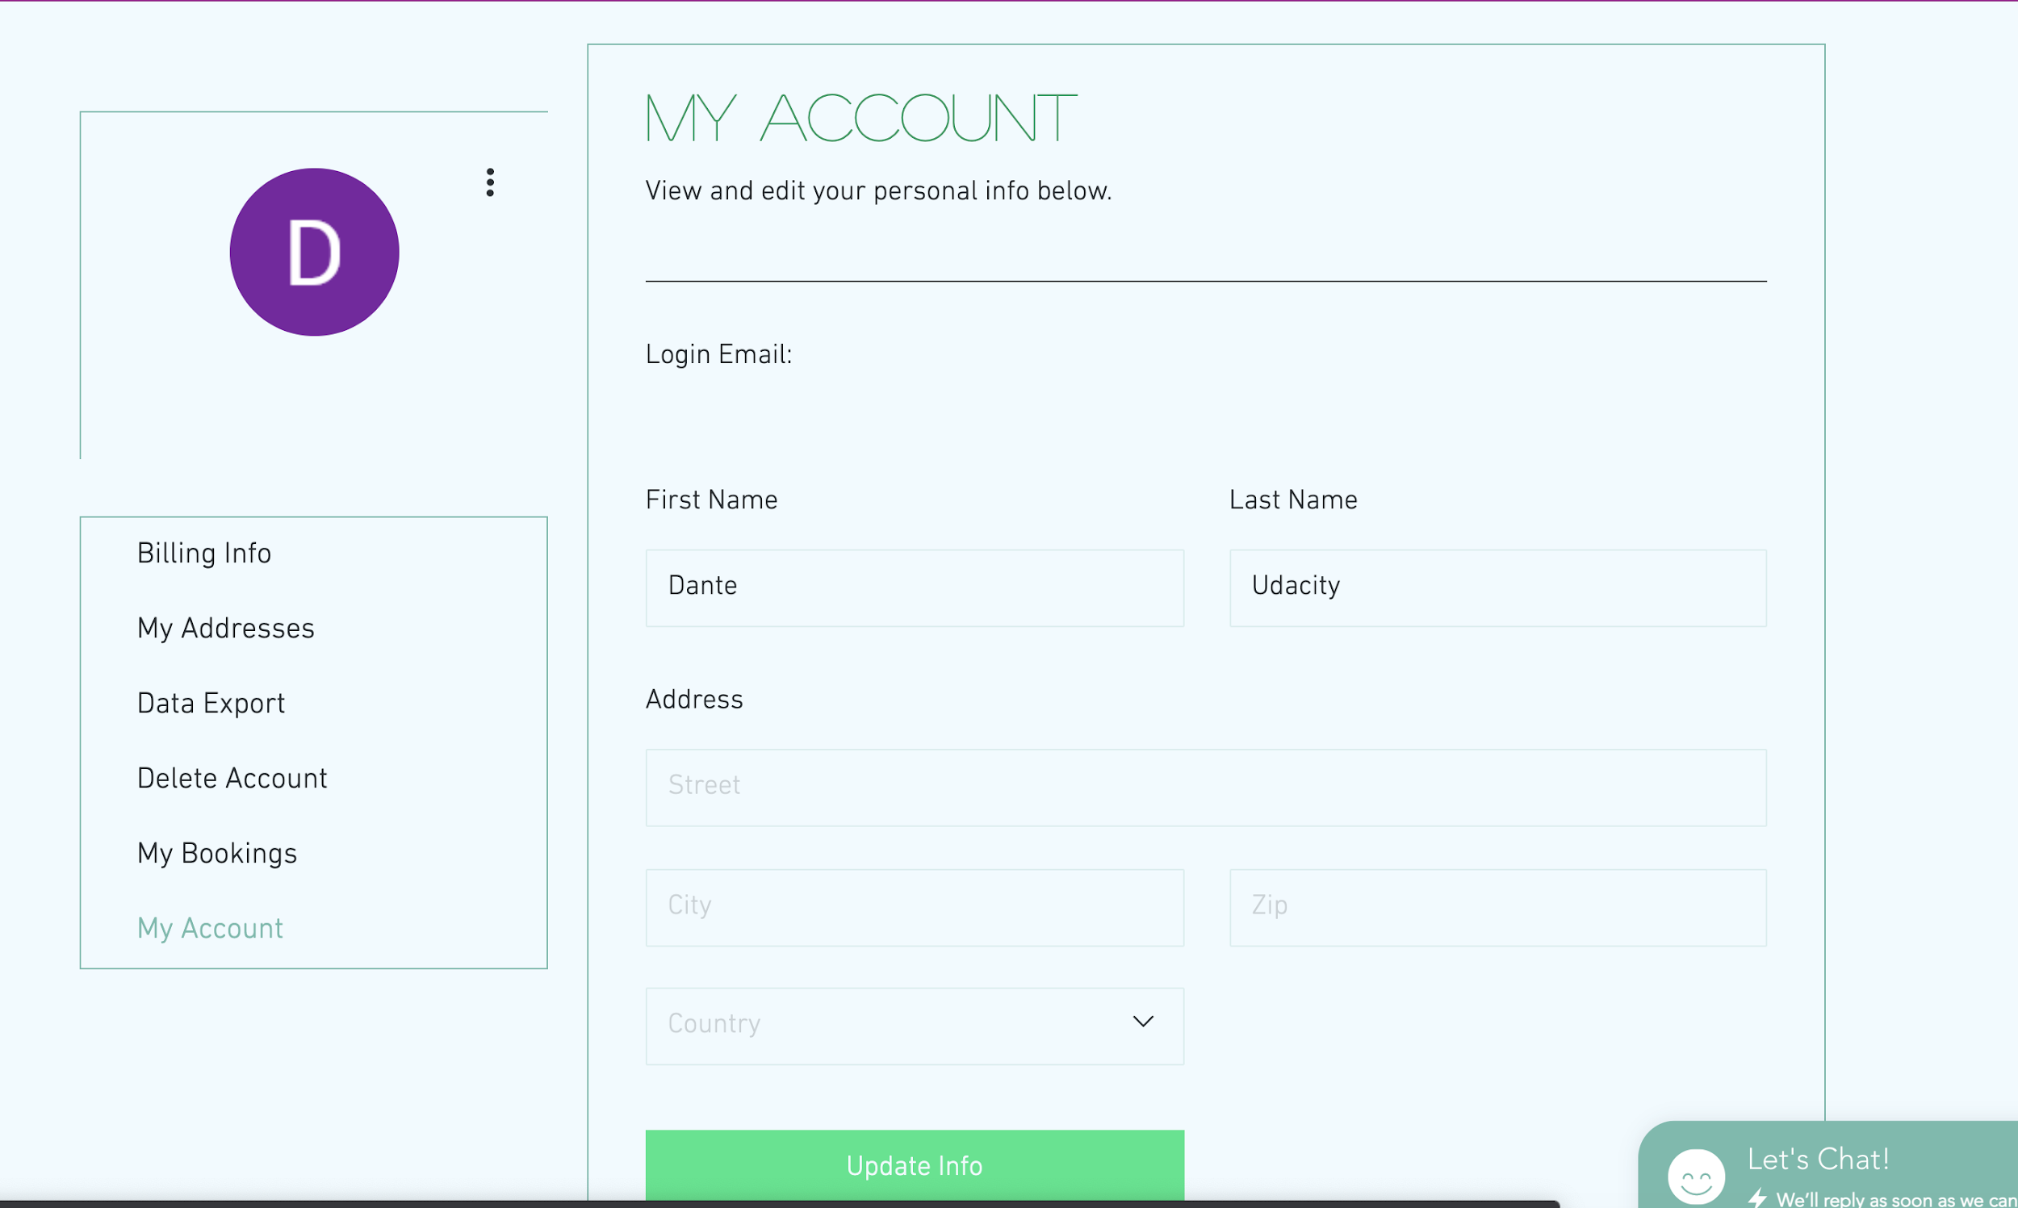

Details about Image 3:

* Account main page
* Provide options to edit:
  + First Name
  + Last Name
  + Home Address
* Menu options include
  + Billing Info
  + Data Export
  + Delete Account
  + My Bookings

# System Design

## Overview

* Customer data is encrypted in transit between the client machine and Udacity Cloud Environment.
* All communication between the servers and databases in the Udacity Cloud environment uses HTTP.
* Data in the databases are encrypted at rest.

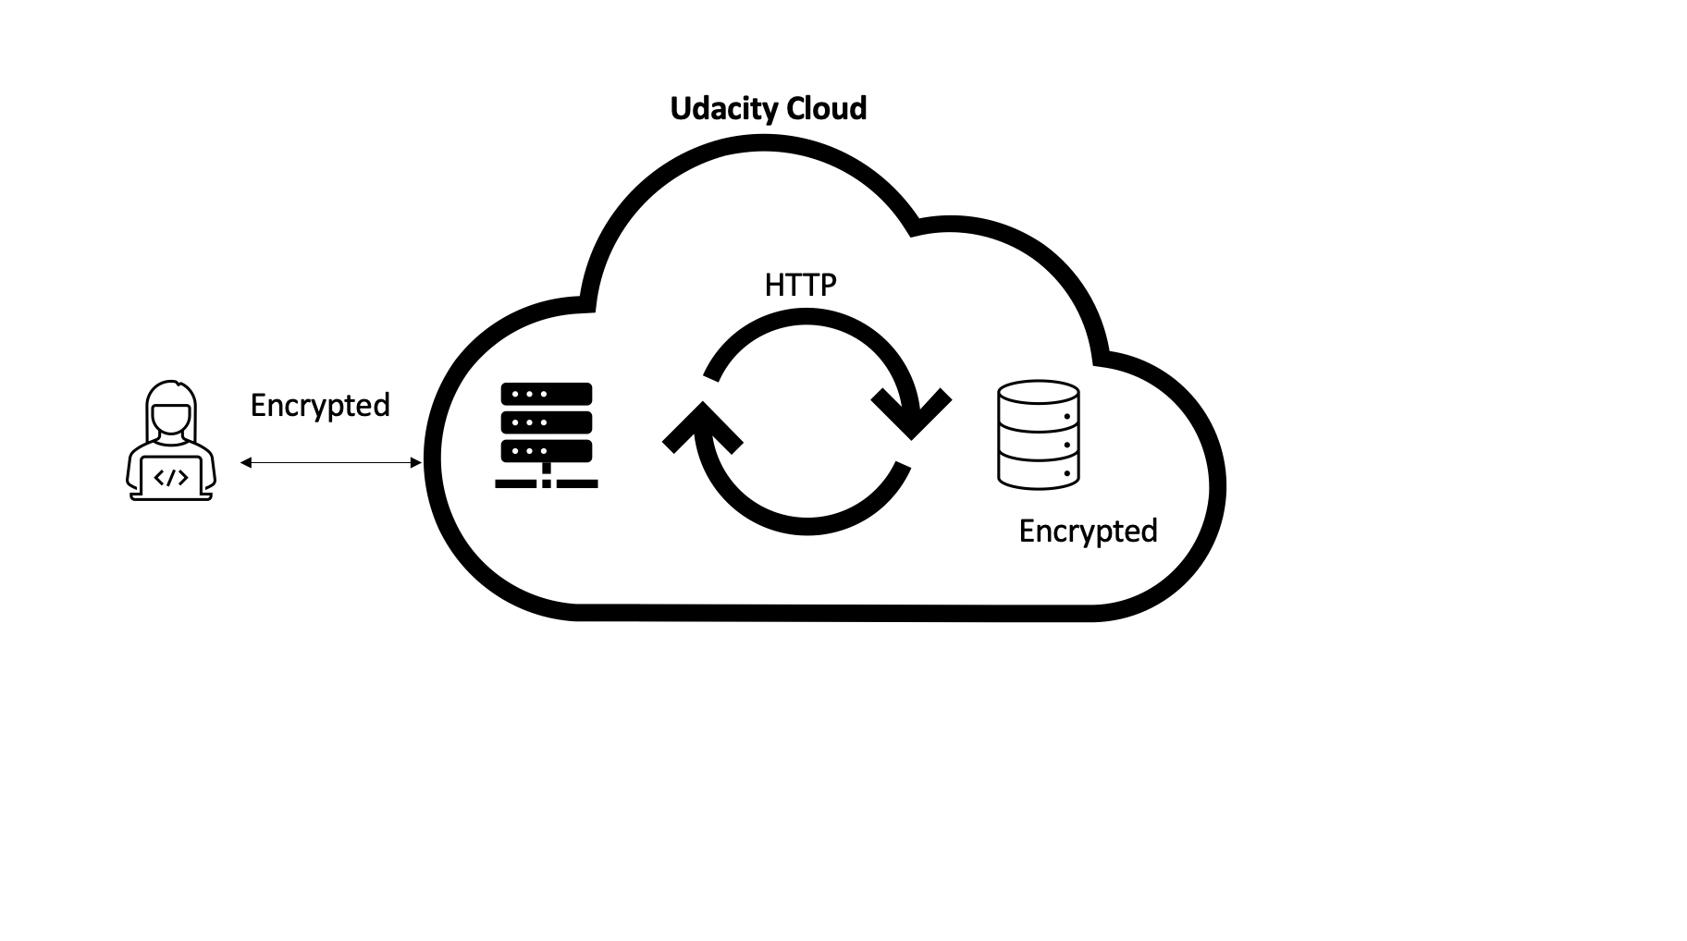

*Image summarizing the system design overview

## Data Collected From User

* First Name
* Last Name
* Phone number
* Home Address
* IP Address
* Ethnicity
* Gender
* Medical History
* Age
* Work History
* Credit Card Data

## Udacity Health Use of the Data

* Udacity Health Analytics team has access to *all* data collected from the users. They will use the data to calculate monthly and weekly active usage.
* Doctors have the capability to download their patients data to their personal devices.
* Udacity Health has prepared a data set to send to a research company. The set of data will be anonymized.

# 

# Description of Key Features

## Schedule Appointments

* Any patient of Udacity Health will be able to schedule an appointment to see a medical specialist.
* The scheduling system will use AI to give preferable times. The AI model will use users profile data (Name, Race, Age, Gender, Address) and medical record to determine who has the most critical need.

## Pay Bills

* Users are able to view their bills and make payments.

## Message Doctors

* Patients are able to send questions to their doctors.

# 

# Privacy Overview

## Data Deletion

When a user deletes their account they are no longer able to access their account or account data. All data is retained in the system for perpetuity.

## Data Export

* Only able to perform export on active account
* The user will get the following information in a .csv format when performing export
  + First Name
  + Last Name
  + Home Address
  + Medical History
  + Age
  + Phone Number